Manuscript templates for conference proceedings

A. Corrauthor ª, B. author ^{b} and C. Coauthor ^{c}
ª Department of Civil and Structural Engineering,
The Hong Kong Polytechnic University, China
Email: a.corr.author@polyu.edu.hk
^{b} Department of Civil Engineering, The University of Hong Kong, China
^{c} ABC Corporation, U.K.

Abstract

The first section of the paper should be a single-paragraph abstract of up to 150 words, outlining the aims, scope and conclusions of the paper.

Keywords: (up to five)

Subject area: (Please put a “X” as appropriate, you may choose more than one)
Transportation Surveys
Travel Behaviour Modelling
Transportation, Land Use and Built Environment
Transportation and Quality of Life
Transportation and Climate Change
Transportation Infrastructure
Technology, Transportation and Telecommunications
Logistics and Supply Chain Management
Transport Dynamics
Regional and International Transportation
Others

Preferred mode of presentation: (Please put a “X” as appropriate)
 | Oral presentation only |  | Poster presentation only
 | No preference

Name of presenter/key speaker:

INTRODUCTION

The full paper, in MS Word 2003 compatible format (if you are using MS Word 2007 or higher, please save the manuscript as a “doc” file), should be submitted to cts.6th@gmail.com by 20 March 2014.

The manuscript should be in English. Please use the preset styles in this manuscript template for formatting. Please read “Apply a different style” in Microsoft Office Word Help if you are not familiar with how to use the preset styles.

PAPER FORMAT

Margin

Set the paper size to A4 (210 mm wide by 290 mm deep) with 25 mm margins on all sides.

Fonts

Font size is Times New Roman typeface in 11 point pitch. For paper title, please set Bold and ALL CAPITALS.

Single Spacing

Paper Length Limit

The paper length limit is 8 pages maximum, including figures, tables, references, and appendices.

Paragraphing

- Leave a blank line between paragraphs without indent.
- Text should be left and right justified across whole page width, providing a vertical margin on both sides.
- Two blank lines must be left before each title of the sections and one blank line before each title of the subsections and sub-subsections, with the exception of new pages.

STRUCTURE OF PAPER

Covering page

The first page of the manuscript must contain the following, and in the order specified below:

- The Paper Title
- The Author Name(s)
- Author Affiliation(s)
- An Abstract
- Up to five keywords
- Subject area
- Preferred presentation session type
- Request for publication in the Proceedings

Positioning of Paper Title, Author Names and Author Affiliations

- Paper title to be centred
- Leave one blank line between the paper title and author names.
- Leave one blank line between author names and author affiliations.
- Both author names and author affiliations to be centred.
- Leave two blank lines between author affiliations and abstract.

Second and following pages

These include the main body of the paper, divided into sections and (optionally) subsections with sub-subsections. Sections must be numbered and their title typed in bold capitals (for example, 1. SECTIONS).

Subsections must be numbered using two digits and their titles typed in bold typeface (for example, 1.1 Subsections). Sub-subsections must be numbered using three digits and their titles typed in bold typeface (for example, 1.1.1 Sub-subsections). Two blank lines must be left before each title of the sections and one blank line before each title of the subsections and sub-subsections, with the exception of new pages.

EQUATIONS, TABLES AND FIGURES

Equations

Equations must be typeset with the same word processor. You may also type the equation in Mathtype (which is available at www.mathtype.com , with 30 days free trial), and use its default setting. All equations must be numbered and appeared in the following format (font type must be TIMES NEW ROMAN):
a + b = c (1)

Tables

Tables are to be centred. Tables must be numbered sequentially, with their title centered above the table. Example:

Table 1. Sample of Table
Regions | A | B
Asia | 4 | 50%
Europe | 3 | 40%
Africa | 3 | 20%
America | 4 | 50%

Figures

All Figures will be reproduced in black and white. They must be drawn in ink or with good quality graphic software. Figures are to be centred, with the reference and caption to be centred below the figure. All Figures must be quoted in the text. Example:

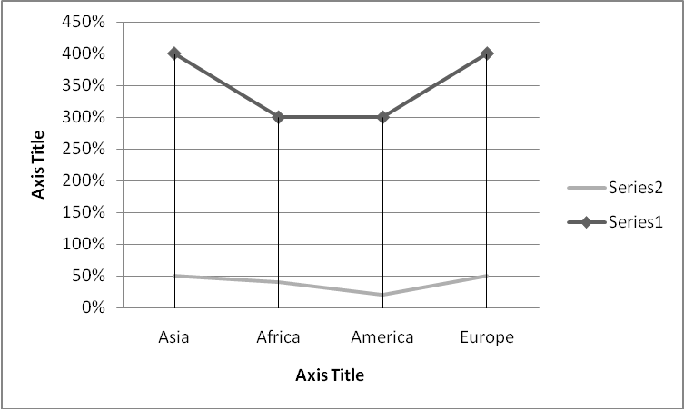
Figure 1. Sample of figure

REFERENCES

The Harvard System of referencing must be used (see, for example, Transportmetrica). In the body of the text, papers or documents are referred to by the author’s surname with the year of publication in parenthesis; if the quotation is itself in parenthesis, the year of publication is separated by a comma. If the reference has more than two authors, only the surname of the first author followed by et al. in italics will appear in the body of the text.

At the end of the paper, complete references must be given alphabetically by author’s surname including: surname(s) and initials of author(s), separated by a comma, year of publication in parenthesis, title of the paper, title of the journal in italic typeface, volume of the journal, and first and last pages. In the case of books, the title of the book must be in italic typeface, with first letter capitals; the publisher and the city of publication must also be indicated. Examples:

Kanafani, A. and Abbas, M.S. (1987) Local air service and economic impact of small airports. Journal of Transportation Engineering 113, pp. 42-55.
Button, K.J. (1982) Transport Economics. Heineman, London.
Nash, C.A. (1988) Integration of public transport: an economic assessment. Bus Deregulation and Privatisation: An International Perspective, eds J.S. Dodgson and N.P. Topham, pp. 17-46. Wiley, New York.
Grant, R.A. (1989) Building and testing a causal model and information technology’s impact. Proceedings of the Tenth International Conference on Information Systems, Boston, MA, pp. 173-184.
Cardell, N.S. (1989) Extensions of multinomial logit: the hedonic demand model, the nonindependent logit model and the ranked logit model. Ph.D. Thesis, Harvard University, U.S.A.

